Element Mover 

*(Updated 2015-09-09 by Jinsol Kim)*

## Overview

The Element Mover will copy elements from a selected linked instance into the current Revit model or update the mapped elements based on the changes made on corresponding source elements in a linked instance. When duplicating elements, two types of mapping, element-level and family type-level of mappings, can affect to the command. By the limitation of API, this tool will be only available in Revit 2015 and 2016.

## Installation

In HOK Add-ins Installer, select one of target software among Revit 2015 or 2016 and select the Element Mover from the list of tools to install.

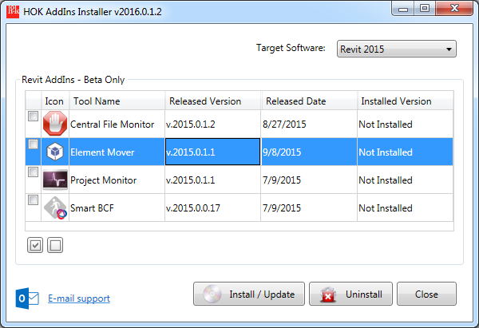

Contents

[Overview 1](#_Toc429572951)

[Installation 1](#_Toc429572952)

[1. Collecting Categories 3](#_Toc429572953)

[2. Mappings 4](#_Toc429572954)

[2.1 Element Mappings 4](#_Toc429572955)

[2.1.1 By Duplication 4](#_Toc429572956)

[2.1.1 By Users 5](#_Toc429572957)

[2.2 Family Mapping 5](#_Toc429572958)

[3. Update Mode 6](#_Toc429572959)

[3.1 Update Location Only 6](#_Toc429572960)

[3.2 Replace Elements 6](#_Toc429572961)

[4. Modeless Dialog and DocumentChanged Event 7](#_Toc429572962)

# 1. Collecting Categories

This tool will collect the information of categories from each Revit link instance by traversing model elements that have material quantities, MEP curves like pipes, ducts, and manually added four categories, Rooms, Levels, Grids, and Scope Boxes.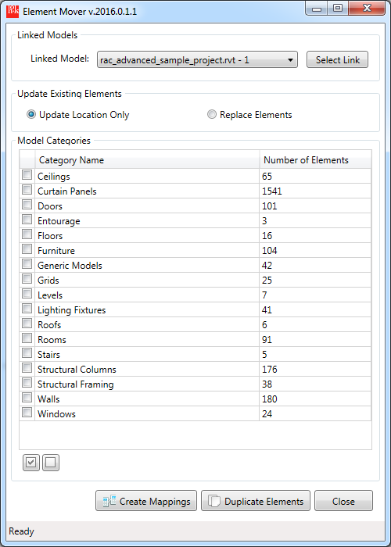

**Select Linked Revit Model**

From the drop-down list of Linked Model, select an item of a linked model or the Select Link button will activate the mouse cursor to be able to select a linked model in the background Revit session.

# 2. Mappings

## 2.1 Element Mappings

### 2.1.1 By Duplication

When the Element mover copies over elements from a linked model, the tool will store the information of the source element into an entity attached to the copied element. You can check existing element mappings by opening the mapping window through the Create Mappings button, . Under Element Mappings tab, mappings will be categorized by their categories, families, and types in the tree view.

When you mouse hover the mapping item, the tooltip will describe the type of the mapping, either “Created by Duplication” or “Defined by Users”. When clicking the node of the mapping item, the copied elements will be selected and the background Revit view will be zoomed in to fit to the screen.

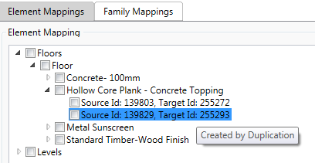

### 2.1.1 By Users

Users can manually define one-to-one relation between a linked element and an element in the host model. The Add Link button C:\Users\Jinsol.Kim\AppData\Local\Temp\msohtmlclip1\02\clip_image001.png will guide you to select two elements in a specific sequence, firstly one element from the linked model and secondly another corresponding element from the host model. After selecting two elements the mapping UI will be updated with the element Ids and tooltip text as Defined by Users.

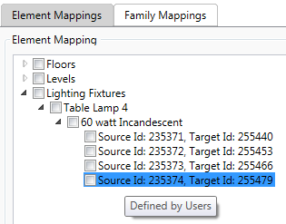

Created links can be removed by selecting the check boxes of the mapping node and pressing the Remove Link button.

## 2.2 Family Mapping

Users can define not only for the element-to-element maps but also family type-to family type maps between linked model and the host model. From the Family Mappings tab, users can start creating family type mapping by pressing the Add Link button. The Family Mapping window will provide the list of families from the linked model and the host model in a certain category.

Machine generated alternative text:
Family Mapping 
Select Families 
Category: -ghting Fixtu 
Source Family. 
Source Type: p-D-66N28T8 
Target Family 
Target Type: 
2440mm - 277V 
Cancel 
Apply 

While the tool duplicate elements into the host model, if the family type of the source element exist among already created family maps, corresponding target family and the type will be placed in the host model instead of simply coping elements. In case of family maps in categories of system family e.g. Floors, Walls, and Roofs. The tool will copy the source element into the host model and change the type as defined in the family map.

\*\*Tips: If an element map already exist for a source element, the family map will be skipped for the element.

# 3. Update Mode

While duplicating elements, if elements with maps found, the tool will handle those existing elements in two different ways depending on the selection of Update Mode.

## 3.1 Update Location Only

This mode will simply update the location of the target element to be placed in the same point or curve location as the source element in the linked model.

## 3.2 Replace Elements

If this mode is selected, existing elements with the maps will be deleted first and create new elements with the updated maps.

# 4. Modeless Dialog and DocumentChanged Event

 The Element Mover is built as a modeless dialog box which allows the user to interact with the model elements and UI components in Revit without closing the dialog box. By the help of the modeless dialog, users can select mapping elements in the Revit session while the Element Mover window is opened and display updated maps in the UI. If elements that have maps are deleted by users, this information will be applied to the list of element mappings and display updated info in the mapping window.